Create External View

Note: External view can be seen in SE11.

1) Go to ABAP Perspective

2) Right click on package Z001- New-Other ABAP Repository Object.

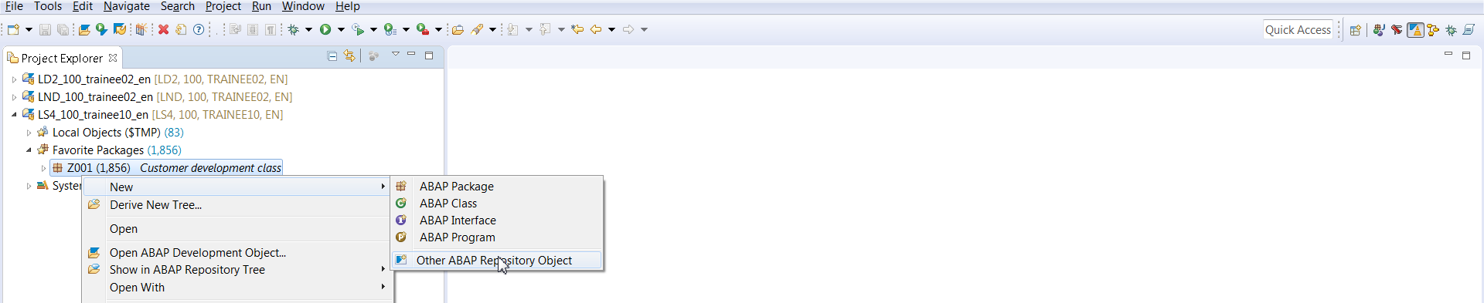

3) Search for Dictionary view

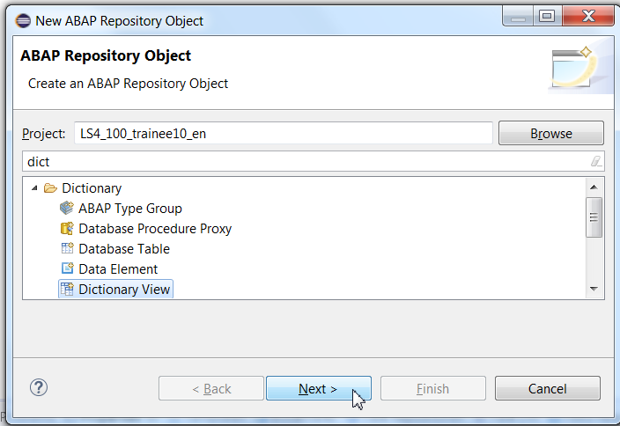

4) Give any name to the view. This view will be later visible in SE11. Hence, view name must start with Z.

Click on the Browse button. Note: Dictionary View name must begin with Z.

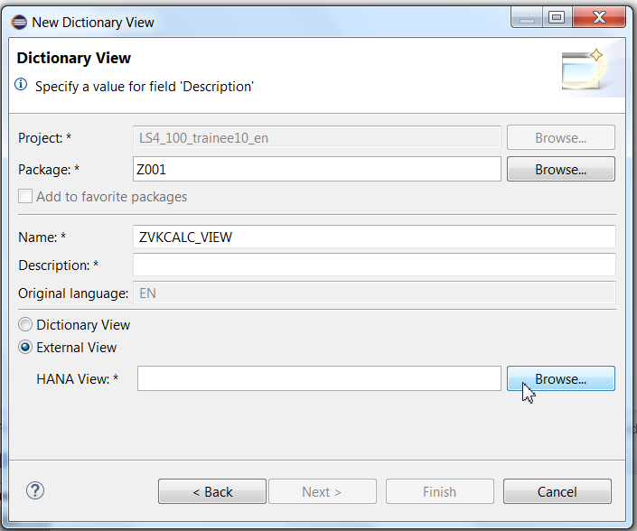

5) Select the view name as shown below.

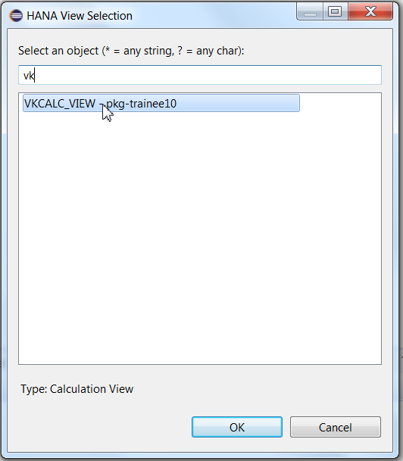

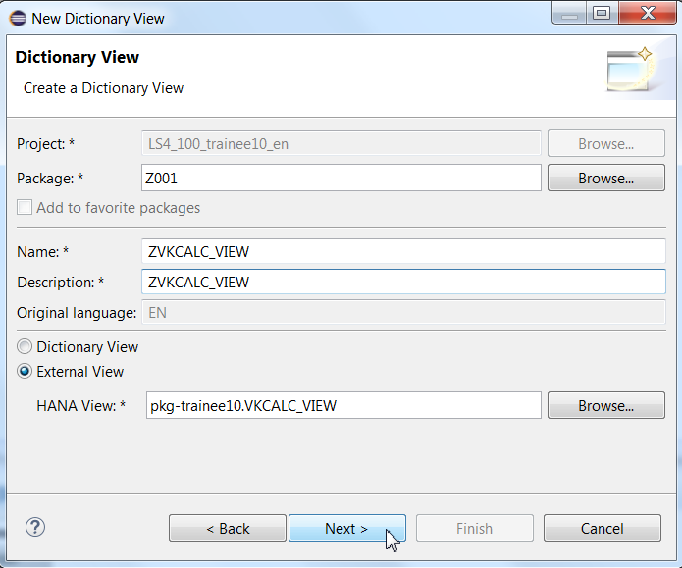

6) Choose any package and Finish

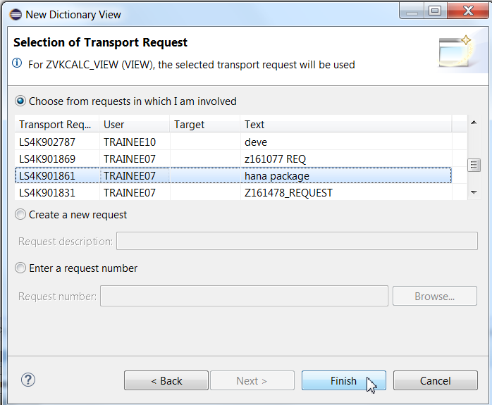

6)Synchronize.

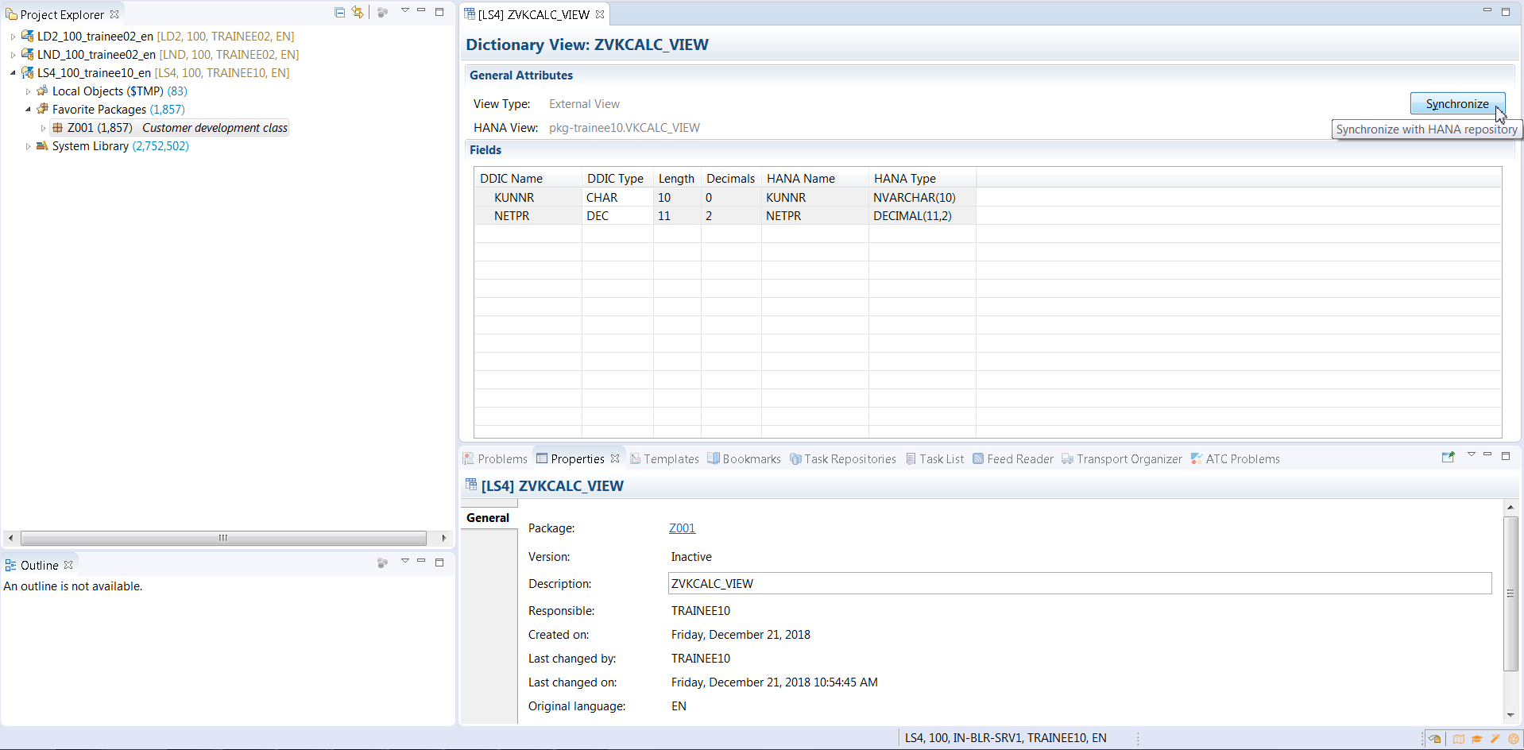

7) See the view created. Scroll down.

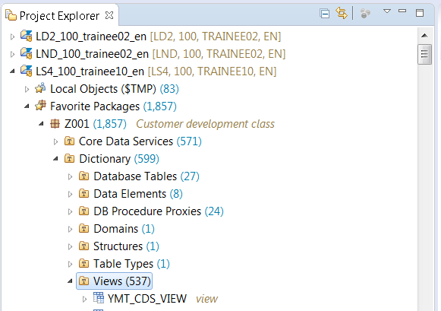

8) Activate it.

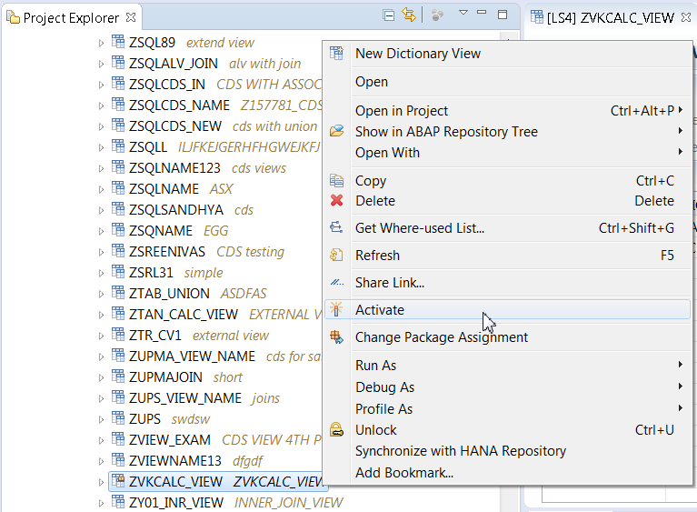

9) Check the view in SE11.

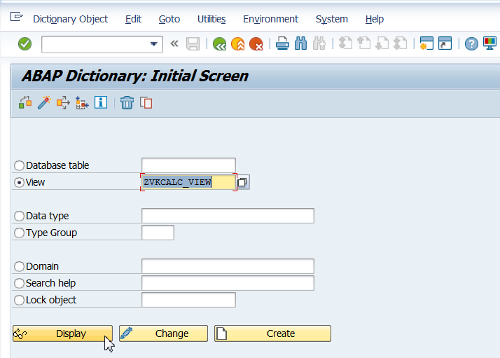

You can see the contents of the view.

12) Switch to Eclipse. Right Click on the view and click on Run AS – ABAP Application.

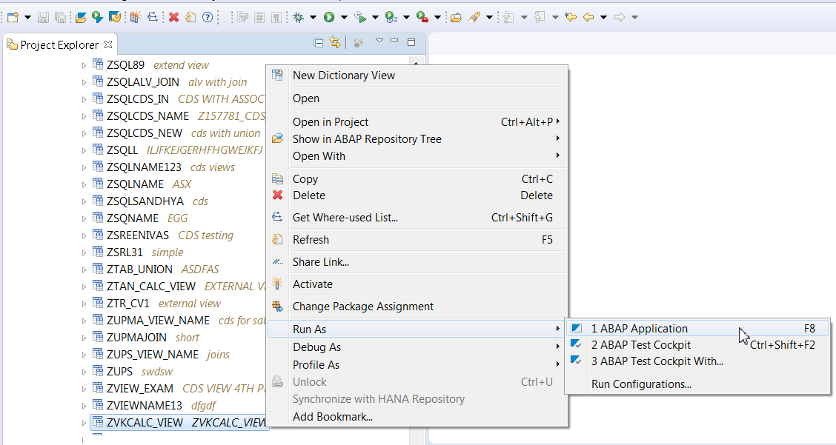

8) See the output.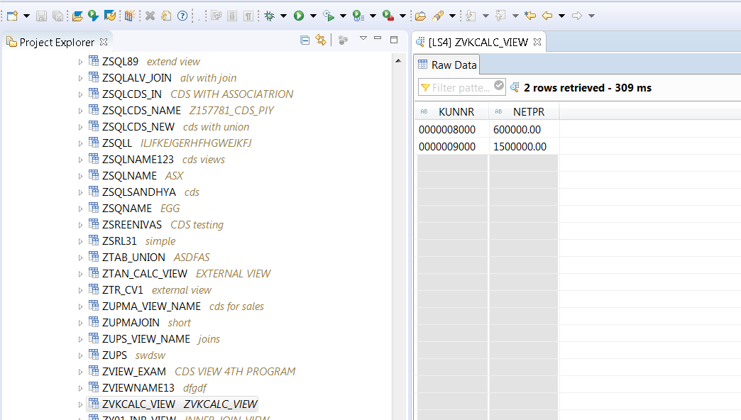

9) Create SE38 program with below code

REPORT Z.  
  
DATA IT_SALES TYPE TABLE OF ZVKCALC_VIEW.  
  
SELECT * FROM ZVKCALC_VIEW INTO TABLE IT_SALES.  
  
CL_DEMO_OUTPUT=>DISPLAY(  IT_SALES ).

10) Check the program.

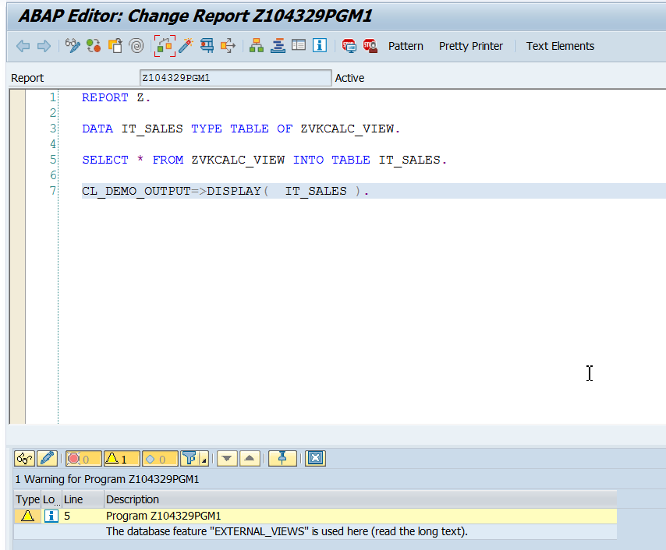

10)Save, Activate and Execute.